SQL ASSESMENT

QUESTION1)

1. Ename and sal whose salary is greater than 2200.

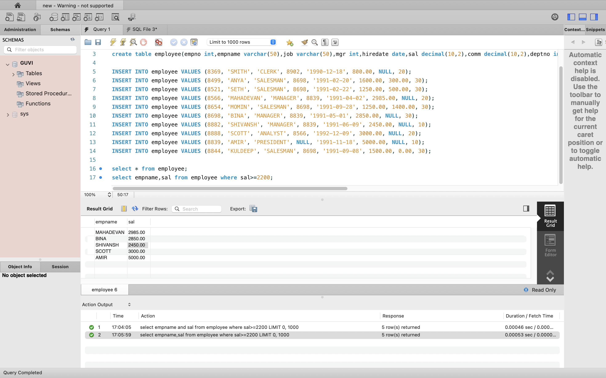

1. Those who are not getting commision.

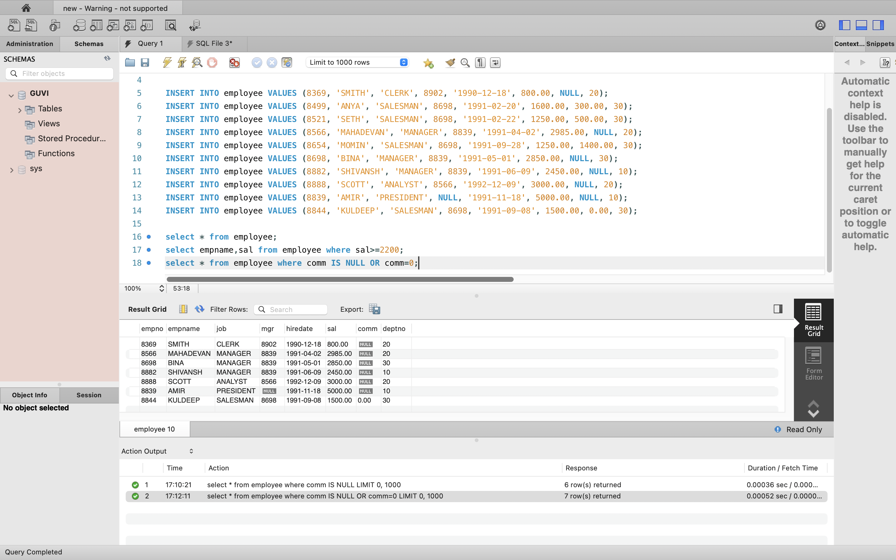

c) who dont have the sal in the range of 2500 to 4000

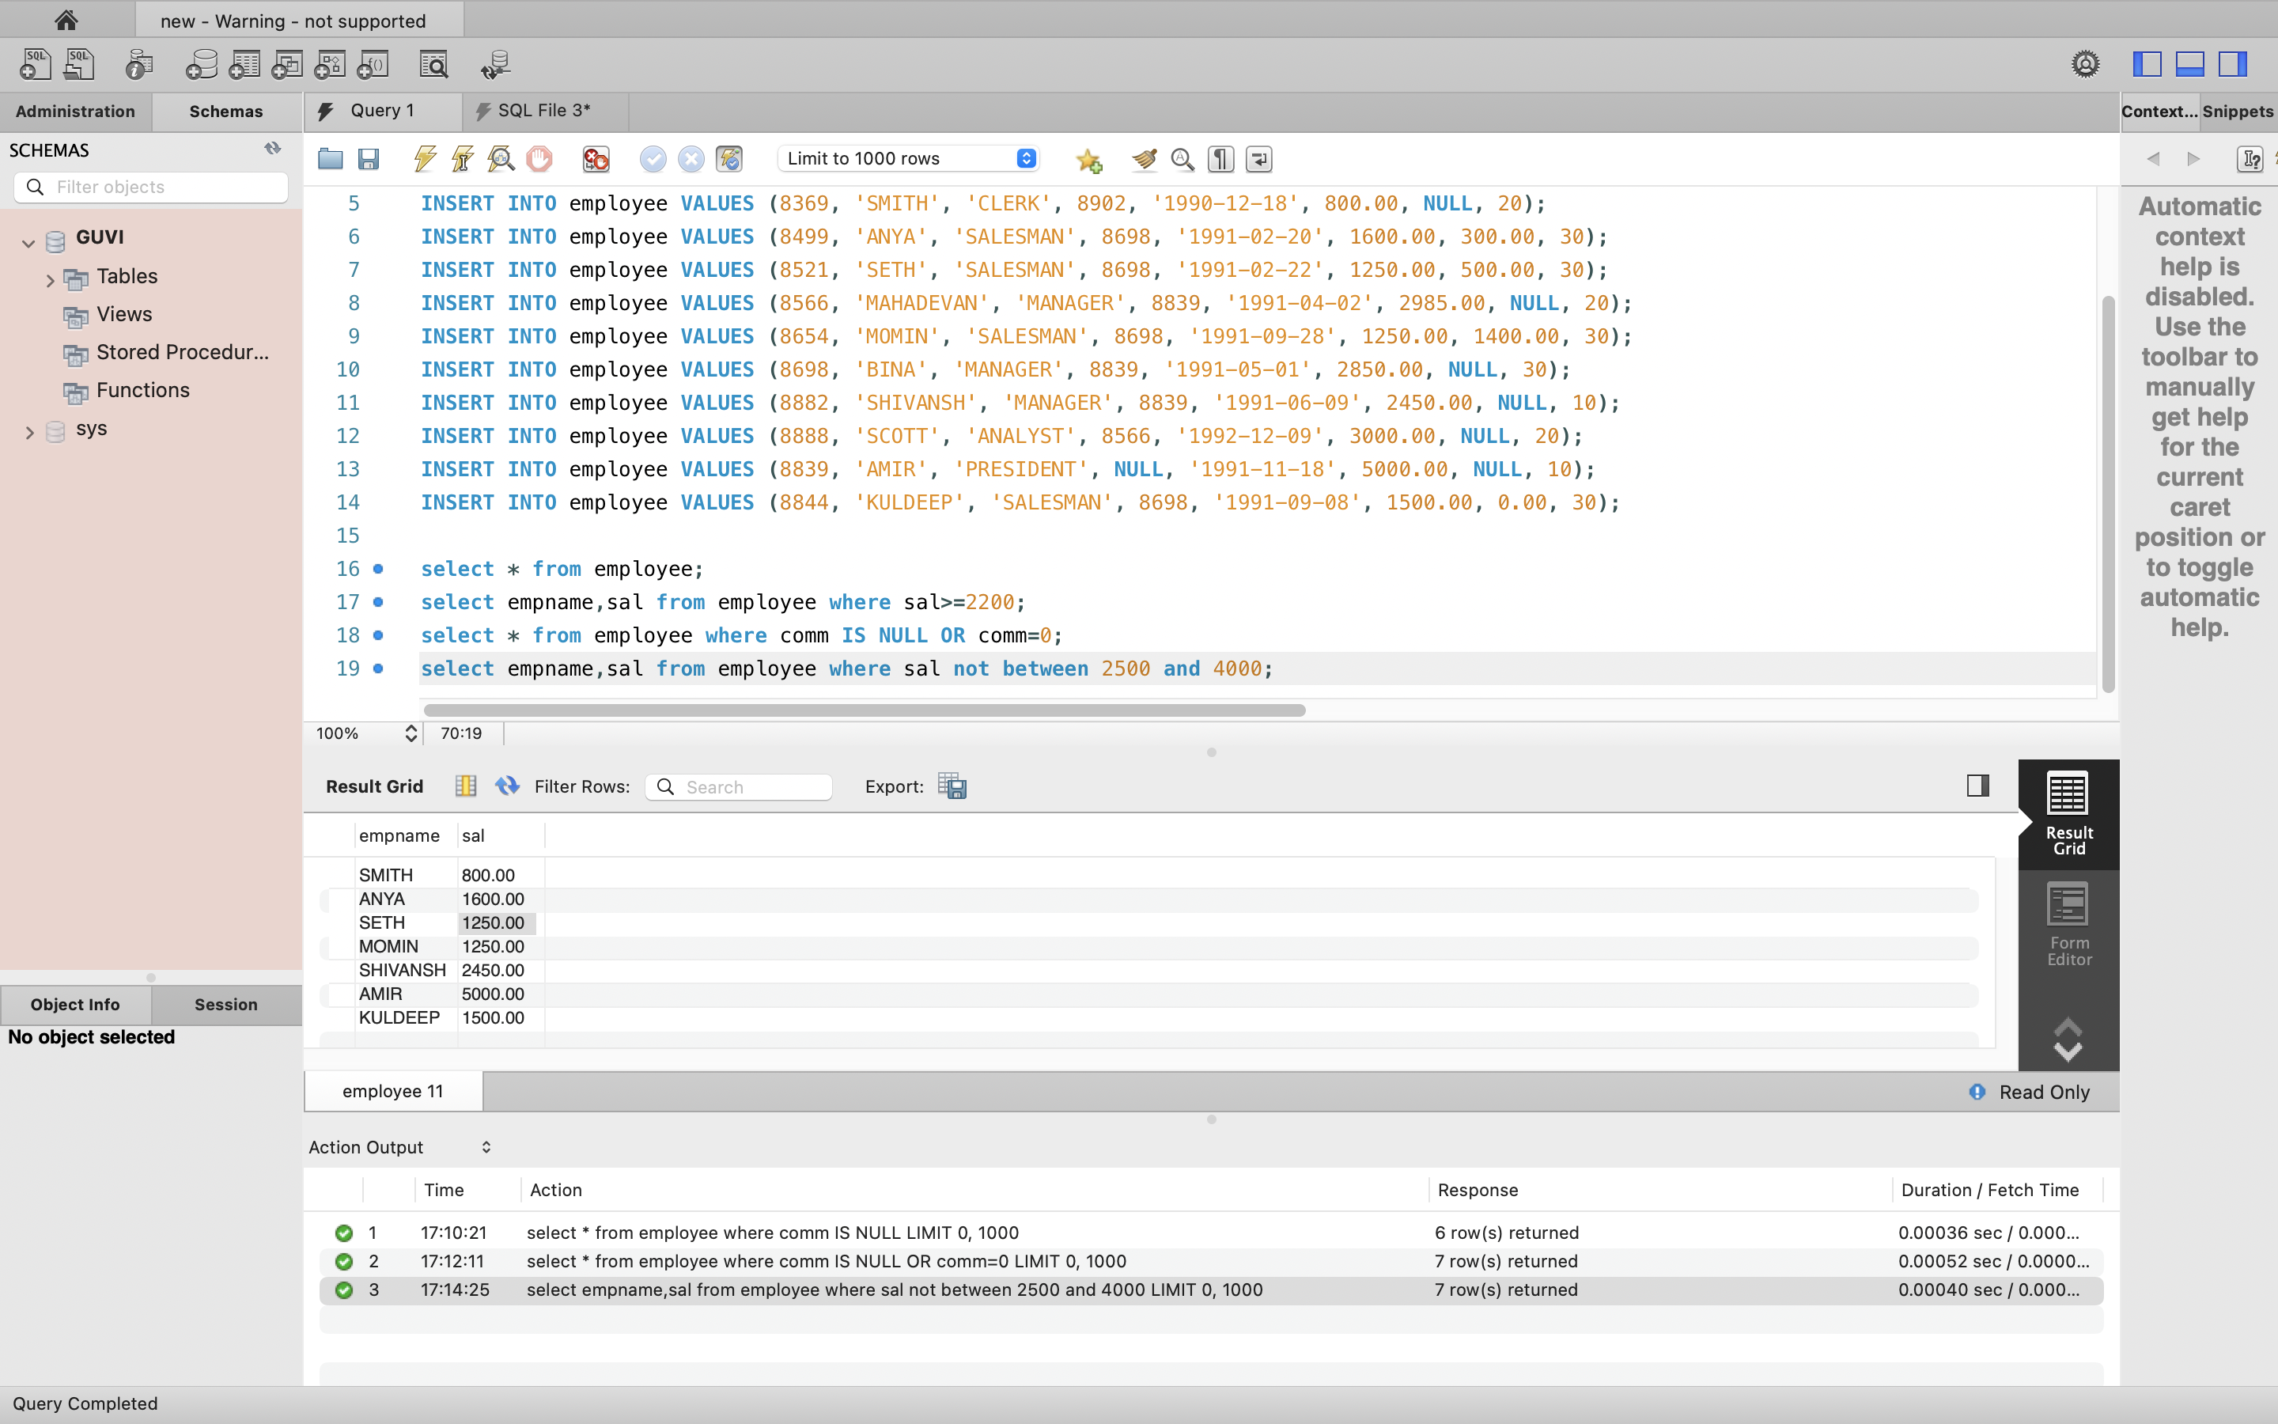

d) who dont have a manager

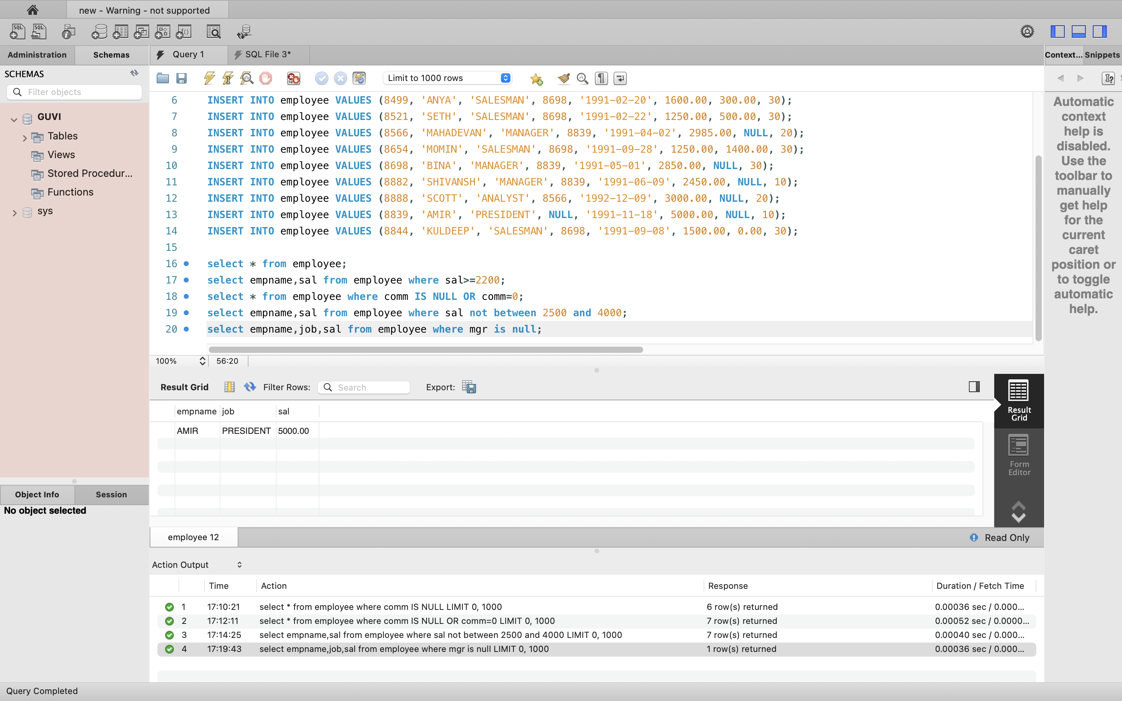

e) whose name contains “A” as the third alphabet

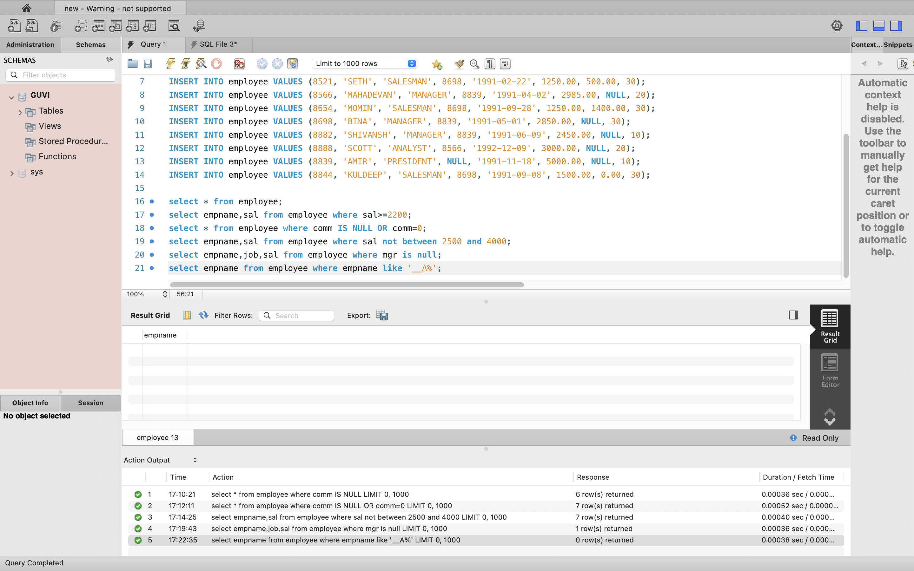

f) whose name have ‘T’ as the last alphabet

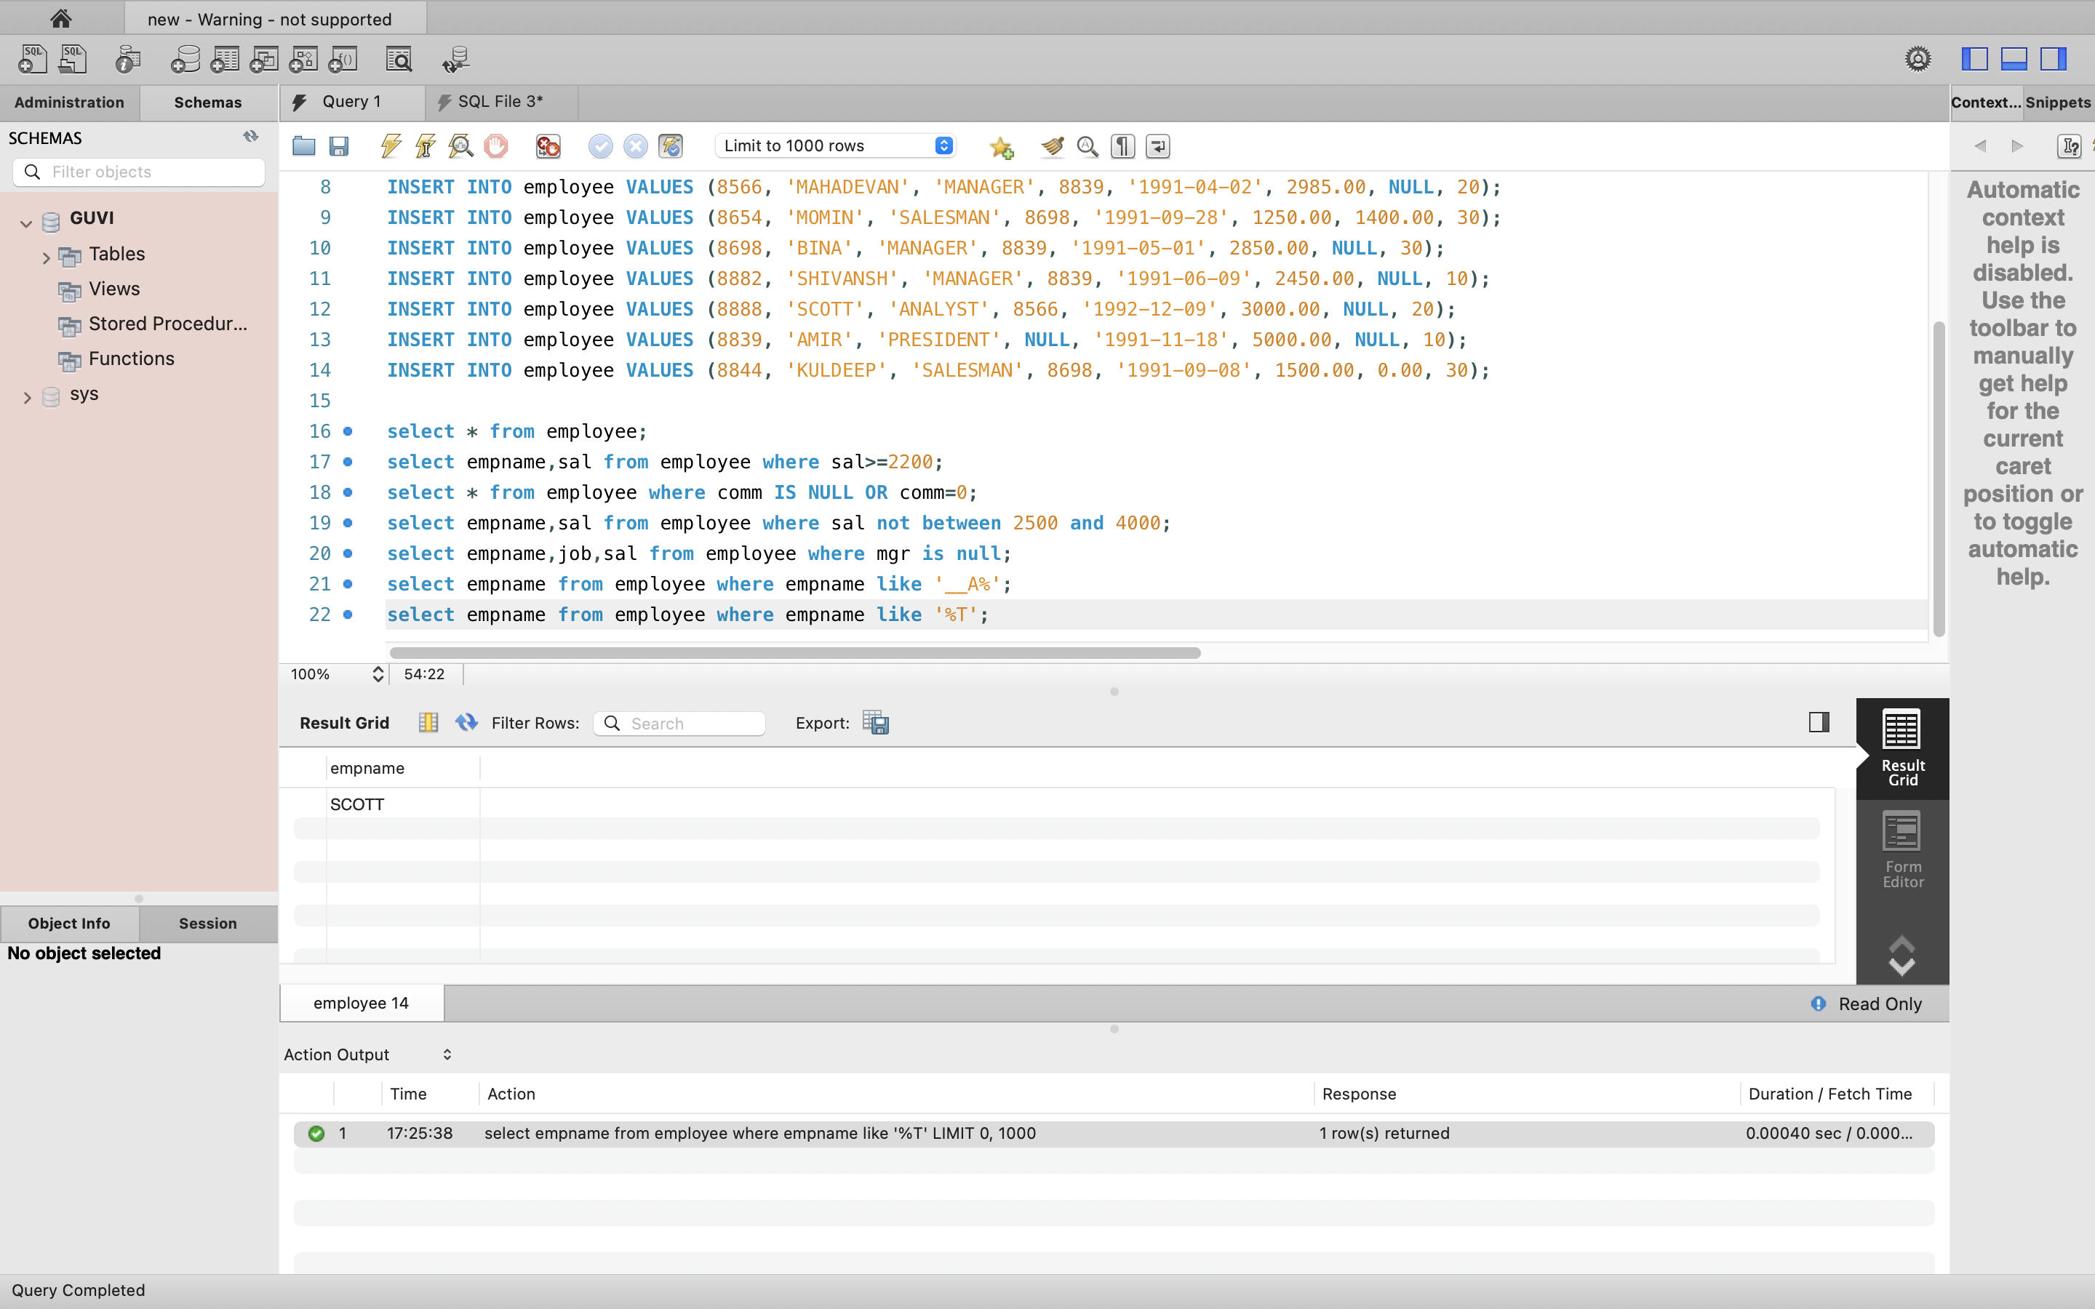

Question 2

JDBC CONNECTION

